JACKET ORDER FORM

Price: €45

**Please choose from a wider fit or narrow fit jacket. If you require smaller than these regular sizes please choose age 11-12 or 13-14**

Result Jacket RS230M (Wider fit)(measurements in cms)

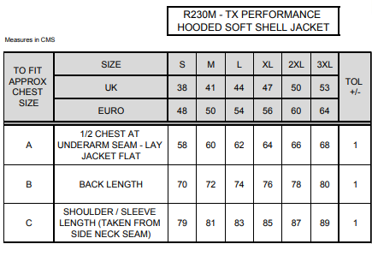
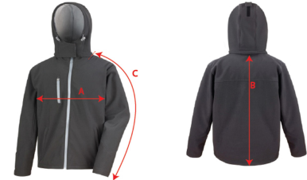

Result Jacket RS230F (Narrower fit)(measurements in cms)
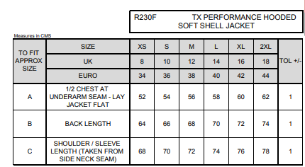

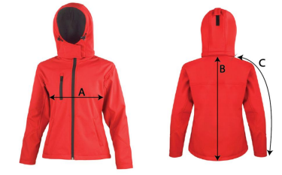

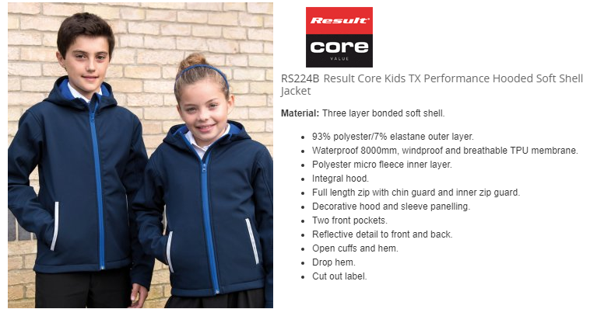

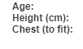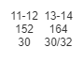
PAYMENT IN FULL REQUIRED ON PLACING ORDER

 | SIZE & CODE | QUANTITY
JACKET

PUPIL’S NAME:

SCHOOL: ST ANNES COMMUNITY COLLEGE KILLALOE

PARENT/GUARDIAN CONTACT NUMBER:

Please complete form and either post it to Address on this sheet or email to
carmel@allseasonssport.ie. Payment either by cheque/cash/postal order or banking online.
Please do not hesitate to contact me to discuss sizing spec or any other query.

Jackets are ordered and embroidered with school crest especially for your child. Please ensure you are happy with sizing prior to ordering as returns will not be possible. There will be a blank name label on the back of the inside of bottom of the jacket. Pupils name to be written on this.

Delivery of the jackets will be in September when the school reopens.

