 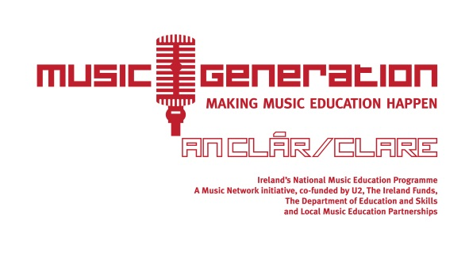

**KILLALOE INSTRUMENTAL HUB**

**APPLICATION FORM FOR SCHOOL YEAR 2020/2021**

1. Student’s name: _______________________________________________________________
2. Student’s age: _________________________________________________________________
3. School currently attending: _____________________________________________________
4. What school year/class is student currently in: ____________________________
5. Which class are you applying for (please tick):

□Beginner Guitar; □ Intermediate Guitar; □Ukulele;

□ Beginner Fiddle; □Intermediate Violin; □Accordion;

□Bodhrán; □Singing/Song writing; □Music Technology & Production

1. How long has your child been learning: _____________________________________________
2. Parent/Guardian’s name:________________________________________________________
3. Parent/Guardian’s email address: ________________________________________________
4. Parent/Guardian’s contact number(s): ___________________________________________
5. Signature of parent/guardian: Date:

*__________________________________ __________________________*

**PLEASE RETURN COMPLETED FORMS BY EMAIL TO: fiona.mcgrath@lcetb.ie**

**PLEASE NOTE, PLACES ARE LIMITED AND OFFERED ON A FIRST COME, FIRST SERVED BASIS.**

**All classes take place in St Anne’s Community College, Killaloe, and commence on Tuesday 15th September 2020 and every Tuesday in term time. Classes are for children in 2nd Class up to 6th Year.**

**Term 1 runs from September to December 2020; Term 2 runs from January to May 2021.**

**Fees: €100 per term. Limited number of instruments available to rent at cost of €50 per year.**

*Music Generation Clare complies with applicable data protection regulations and is committed to GDPR compliance across its relevant services in accordance with General Data Protection Regulations (GDPR) that came into effect on 25th May 2018. As such, the information collected herein will be used for no other purpose than that for which it is intended, it will not be shared with any third party and it will be retained and destroyed as per the Records Retention Policy. For more information, please refer to our Privacy Statement on our website.*