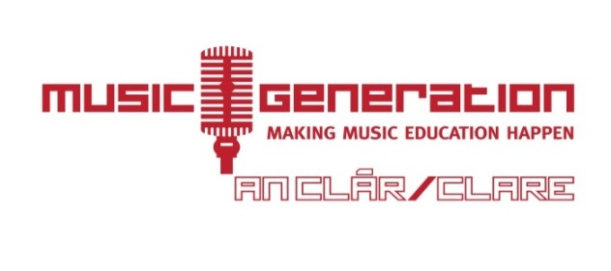
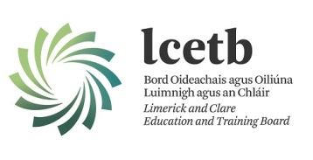

INSTRUMENTAL TUITION COMING TO YOUR SCHOOL IN SEPTEMBER 2018!

In September 2018, Music Generation Clare will be establishing an after school Instrumental Hub in St Anne’s Community College, Killaloe
- Classes will take place every Wednesday after school, between 4pm and 6pm.
The following instrumental tuition will be offered.
- Concertina, Guitar, Bass Guitar, Violin, Banjo, Bodhran, Ukulele, Accordion, Percussion.
All levels are catered for: beginner, intermediate, advanced
- Cost: €90 per 15 week term
Most instruments are available to rent at the cost of €50 for the year (with option to pay this is two instalments of €25)
*Please note, instrumental tuition offered is subject to demand and tutor availability and may change.
If you are interested in taking part, please complete the Expression of Interest form and return it to your school Principal.

MUSIC GENERATION CLARE: WHO WE ARE & WHAT WE DO
Music Generation Clare is part of Ireland’s National Music Education Programme that transforms the lives of children and young people through access to high quality performance music education in their locality. Through partnership, we create rich and diverse ways for participants to engage in instrumental tuition delivered by skilled professional musicians, across all musical genres and styles
Music Generation believes in every child and young person’s musical potential and their innate artistry; that it is every child and young person’s right to have the choice of access and the chance to participate as a musical citizen and that music doesn’t just change lives, it transforms lives.

