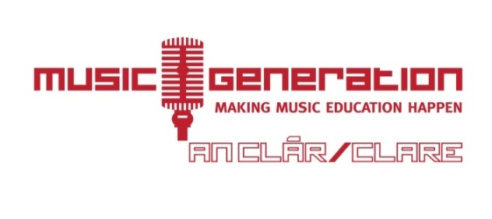
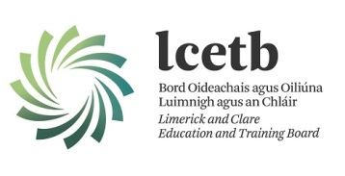

KILLALOE INSTRUMENTAL HUB - EXPRESSION OF INTEREST FORM

- Student’s name: _______________________________________________________________
- Student’s age: _________________________________________________________________
- School currently attending: _____________________________________________________
- What school year will student be starting in Sept. 2018: __________________________________
- Which instruments(s) are you interested in learning (please tick):
□Beginner Guitar; □ Intermediate Guitar; □ Advanced Guitar;
□ Beginner Violin; □ Intermediate Violin ; □Advanced Violin;
□Beginner Concertina; □Intermediate Concertina; □Advanced Concertina;
□ Bass Guitar; □ Banjo; □Ukulele; □ Accordion;
□ Bodhrán; □Percussion;

Other instrument (please specify): _____________________________________________

- Parent/Guardian’s name: ______________________________________________________________
- Parent/Guardian’s email address: _______________________________________________________
- Parent/Guardian’s contact number(s): ___________________________________________________

Signature of parent/guardian: Date:
__________________________________ __________________________

Music Generation Clare & compliance with GDPR
In May 2018, the EU General Data Protection Regulation (GDPR) replaces the existing 1995 EU Data Protection Directive (European Directive 95/46/EC). Music Generation Clare currently complies with applicable data protection regulations and is committed to GDPR compliance across its relevant services when the GDPR takes effect May 25, 2018. As such, the information collected herein will be used for no other purpose other than that for which it is intended, it will not be shared with any third party and it will be retained and destroyed as per the Records Retention Policy.

