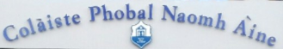
TABLE QUIZ

In aid of:
St Anne’s Community College, Killaloe

Date:
Friday, 20th April 2018

Time:
8.00pm sharp

Venue:
O’Donovan’s Bar – Boru on the Hill
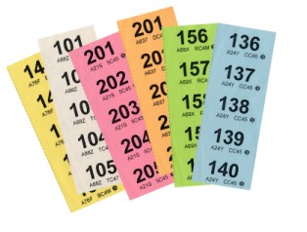
Tables of 4 - €10.00 per head
Raffle on the night with fantastic prizes
Including dinner for 2 at Wood & Bell!!

Will be a great FUN night!

All welcome

Organised by:
Parents’ Association

