Limerick and Clare Education and Training Board,  Marshal House,  Dooradoyle Road,  Co. Limerick. | 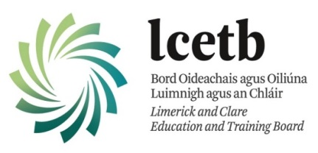 | Your Ref:
 | Form NVB 1
 | Vetting Invitation
Section 1 – Personal Information

Forename(s):
Middle Name:
Surname:
Date Of Birth: | D | D | / | M | M | / | Y | Y | Y | Y
Email Address:
Contact Number:
Role Being Vetted For:
School or Centre:
Current Address:
Line 1:
Line 2:
Line 3:
Line 4:
Line 5:
Eircode/Postcode:
Under Sec 26(b) of the National Vetting Bureau (Children and Vulnerable Persons) Acts 2012 to 2016, it is an offence to make a false statement for the purpose of obtaining a vetting disclosure.

Section 2 – Additional Information
Name Of Organisation: | Limerick and Clare ETB
I have provided documentation to validate my identity as required and
I consent to the making of this application and to the disclosure of information by the National Vetting Bureau to the Liaison Person pursuant to Section 13(4)(e) National Vetting Bureau (Children and Vulnerable Persons) Acts 2012 to 2016. Please ✔ tick box

Applicant’s
Signature: |  | Date: | D | D | / | M | M | / | Y | Y | Y | Y
NOTE: PLEASE RETURN THIS FORM TO YOUR SCHOOL OR CENTRE. An invitation to the e-vetting website will then be sent to
your Email address.

